

Worksheet No. - 1

Student Name: Anjali kumari UID: 25MCA20023
Branch: MCA general Section:Group:1/A
Semester: 2st Date of Performance:21th of jan
Subject Name: TECHNICAL TRANNING LAB.

Subject Code: CONT_25CAP-652.

- Aim/Overview of the practical: To write a C program that reads an infix expression and converts it into postfix and prefix notations using stack operations.
- Objective:
Understand infix, postfix, and prefix expressions.

  - Apply stack data structure for expression conversion.

  - Implement algorithms for infix to postfix and prefix conversion.

  - Understand operator precedence and associativity.

  - Execute, test, and validate the conversions with examples.

Procedure/Algorithm:
Algorithm (Infix → Postfix):
- Scan expression left to right.
- Add operands directly to output.
- Push '(' onto stack.
- On ')', pop until '('.
- For operators, pop operators of higher/equal precedence.
- Pop remaining operators. Algorithm (Infix → Prefix):
  - Reverse infix expression.


  - Swap '(' with ')'.
  - Convert to postfix.
  - Reverse postfix → prefix.
- C PROGRAM
#include <stdio.h> #include <string.h> #include <ctype.h> #define MAX 100 char stack[MAX]; int top = -1;
void push(char x) { stack[++top] = x;
}
char pop() {
if (top == -1) return -1; return stack[top--];
}
int precedence(char x) {
if (x == '+' || x == '-') return 1; if (x == '*' || x == '/') return 2; if (x == '^') return 3;
return 0;
}
void reverse(char str[]) { int i, j;
char temp;


for (i = 0, j = strlen(str) - 1; i < j; i++, j--) { temp = str[i];
str[i] = str[j]; str[j] = temp;
}
}
void infixToPostfix(char infix[], char postfix[]) { int i, j = 0;
char ch;
for (i = 0; infix[i] != '\0'; i++) { ch = infix[i];
if (isalnum(ch)) { postfix[j++] = ch;
}
else if (ch == '(') { push(ch);
}
else if (ch == ')') {
while (top != -1 && stack[top] != '(') postfix[j++] = pop();
pop();
}
else {
while (top != -1 && precedence(stack[top]) >= precedence(ch)) postfix[j++] = pop();
push(ch);


}
}
while (top != -1) postfix[j++] = pop();
postfix[j] = '\0';
}void infixToPrefix(char infix[], char prefix[]) { char rev[MAX], tempPost[MAX];
int i, len;
len = strlen(infix);
for (i = 0; i < len; i++) { rev[i] = infix[len - i - 1];
if (rev[i] == '(') rev[i] = ')';
else if (rev[i] == ')') rev[i] = '(';
}
rev[len] = '\0'; top = -1;
infixToPostfix(rev, tempPost); reverse(tempPost); strcpy(prefix, tempPost);
}
int main() {
char infix[MAX], postfix[MAX], prefix[MAX]; printf("Enter an infix expression: ");
scanf("%s", infix); top = -1;
infixToPostfix(infix, postfix);


infixToPrefix(infix, prefix); printf("\nPostfix Expression: %s", postfix);
printf("\nPrefix Expression : %s\n", prefix); return 0;
}

SAMPLE OUTPUT
Input: (a+b)*c Output: Postfix: ab+c* Prefix: *+abc

OUTPUT:
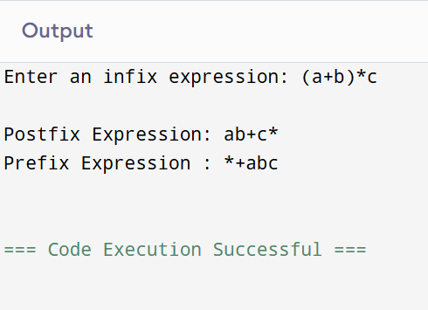



Learning outcomes (What I have learnt):
  - Stack Data Structure
    - Understand LIFO (Last In, First Out) principle.
    - Implement stack operations (push, pop) using arrays.
    - Use stack for expression conversion and evaluation.
  - Operator Precedence and Associativity
    - Recognize precedence rules: ^ > * / > + -.
    - Apply precedence in deciding when to push or pop operators.
  - Expression Notations
    - Differentiate between infix, postfix, and prefix expressions.
    - Learn strategies to convert infix → postfix → prefix.
    - Use reverse-and-swap-parentheses technique for prefix conversion. 4.Character Handling
    - Detect operands vs operators using isalnum().
    - Handle parentheses and operator conditions during conversion.
- String Manipulation
  - Reverse strings manually using loops.
  - Copy strings using strcpy.
  - Traverse strings character by character.
- Input and Output in C
  - Read strings with scanf("%s", ...).
  - Print results using printf.
  - Understand limitations of %s for space-containing input.
- Problem Decomposition
  - Break complex logic into smaller functions (push, pop, infixToPostfix, infixToPrefix).
  - Reset stack (top) for multiple operations.
- Debugging & Logic
  - Trace stack operations step-by-step.
  - Check for edge cases like unbalanced parentheses or empty stack.



